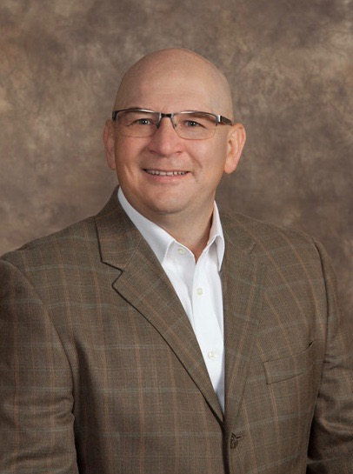

David Taylor MSN, RN, CNOR

David Taylor MSN, RN, CNOR is a nurse leader, consultant, educator, author and nationally recognized speaker who examines the challenges operating rooms and central sterile departments face as healthcare leaders manage their practice in the surgical services environment. In addition,

David has been providing services to clients with various nursing, surgical services, ancillary service line, and business development needs across the United States for over 30 years. From rural to urban, community-based to large academic medical centers and ambulatory surgical centers, his areas of expertise are services that improve operational and clinical efficiencies, while helping organizations function more effectively to improve their market position.

David has assisted a variety of clients throughout the country improve clinical excellence, improve physician, staff, and patient/family satisfaction, all while placing an emphasis on safety and throughput which has resulted in streamlined processes’, increased surgical volumes, and enhanced best practices.

David’s particular area of specialty lies in the operational improvement of Surgical Services and Central Sterile/Sterile Processing Departments (C/SPD). Using a focused approach of best practice assessment, inter-professional collaboration and team based solution development, David consistently assists in developing and executing on solutions that enhance an organizations capabilities and success. David is a member of the Association of PeriOperative Registered Nurses (AORN). He maintains membership in the Business Industry Consulting (BIC) and Leadership Specialty Assemblies and is a long-time member of Sigma Theta Tau International Honor Society of Nursing. He completed his Lean Healthcare Certification at Villanova University, is a nationally recognized speaker and has published in nationally recognized peer review journals on various perioperative and central sterile subjects.

